**BLINKIT SALES PERFORMANCE DASHBOARD**

**FINAL DASHBOARD**

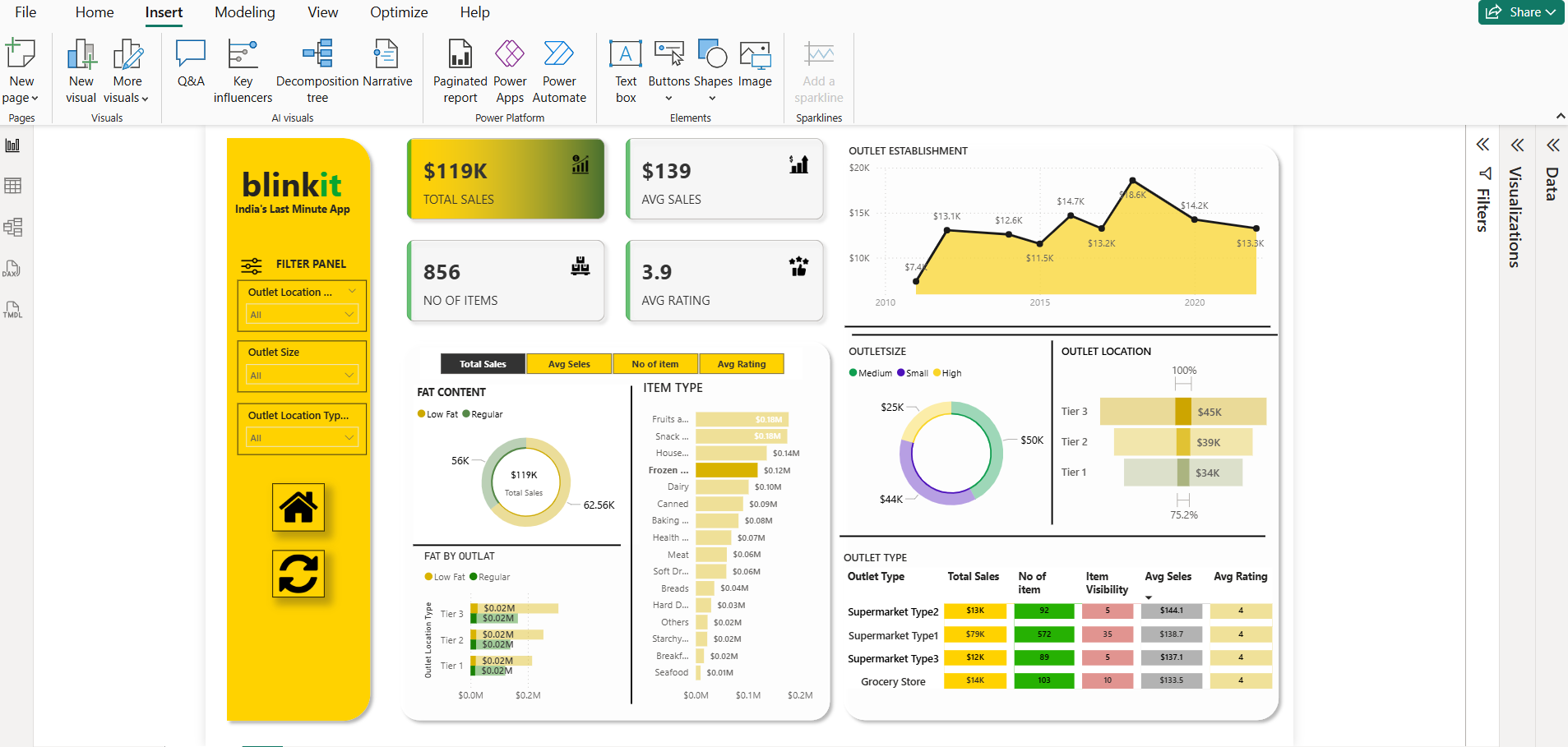

**KPI Requirements**

